**Supply Leftover Food System To Poor**

**1. Project Overview**

This project focuses on creating a "Supply Leftover Food System" using Salesforce. It is designed to address the dual challenges of food wastage and hunger. The system connects food donors, such as restaurants, households, and events, with NGOs, food banks, and individuals in need. By leveraging Salesforce's automation and data management capabilities, this project aims to simplify food donation, streamline logistics, and ensure that surplus food is utilized efficiently and safely.

The goal is to create a centralized platform that enhances food redistribution, minimizes waste, and supports communities in combating food insecurity.

**2. Objectives**

**Business Goals:**

1. Facilitate the redistribution of surplus food to minimize wastage.
2. Establish a transparent and efficient food donation process.
3. Provide real-time tracking for donations and deliveries.

**Specific Outcomes:**

* A portal for donors to list available leftover food easily.
* Automated matching between donors and recipients based on predefined criteria.
* Real-time status tracking for food pickup and delivery.
* Comprehensive analytics for donors and administrators to measure impact.

**3. Salesforce Key Features and Concepts Utilized**

1. **Custom Objects:**
   * **Donations**: Tracks details about food items, quantity, and donor information.
   * **Recipients**: Includes NGOs, food banks, and individuals.
   * **Logistics**: Manages the pickup and delivery process.
2. **Automation Tools:**
   * **Flows and Triggers**: Automate the matching of donations to recipients and manage notification workflows.
   * **Approval Processes**: For verifying food safety and recipient eligibility.
3. **Dashboards and Reports:**
   * Insights into food donations, meals served, and environmental impact.
4. **Community Portals:**
   * Separate portals for donors, recipients, and administrators to manage their respective roles.
5. **Third-Party Integrations:**
   * APIs for logistics services, geolocation mapping, and SMS/email notifications.

**4. Detailed Steps to Solution Design**

1. **Data Model Design:**
   * Objects include Donors, Donations, Recipients, Logistics, and Feedback.
   * Relationships defined to link donations to donors, recipients, and logistics data.
2. **User Interface Design:**
   * **Donor Portal**: Simple interface to log food donations.
   * **Recipient Portal**: Interface to view available donations and request pickup.
   * **Admin Dashboard**: Centralized control for monitoring and managing operations.
3. **Business Logic:**
   * **Matching Algorithm**: Finds the best recipient for each donation based on location, food type, and quantity.
   * **Validation Rules**: Ensure food details meet safety standards.
4. **Integration Points:**
   * Integration with delivery services for efficient food transportation.
   * Geolocation services to optimize routes for pickups and deliveries.

**5. Testing and Validation**

* **Unit Testing:**
  + Apex Classes and Triggers tested to ensure automation reliability.
* **User Interface Testing:**
  + Tested portals and dashboards for seamless user experiences.
* **Integration Testing:**
  + Validated third-party APIs for logistics, geolocation, and notifications.

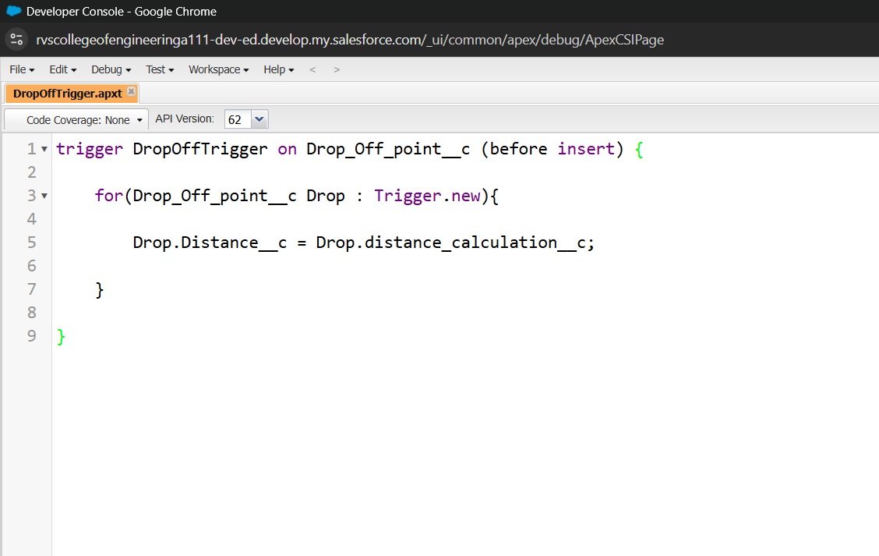

**6. Key Scenarios Addressed by Salesforce in the Implementation Project**

1. **Food Donation Management:**
   * Streamlined process for donors to register and log surplus food.
2. **Recipient Matching and Notification:**
   * Automated selection of nearby recipients with real-time notifications for both donors and recipients.
3. **Delivery Coordination:**
   * Integrated logistics to manage the pickup and delivery of donated food.
4. **Impact Tracking:**
   * Dashboards and reports for analyzing the number of meals served and waste reduced.

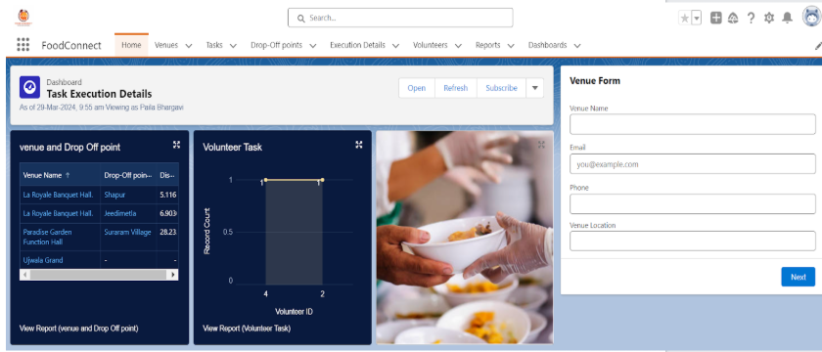

**7. Conclusion**

The "Supply Leftover Food System" leverages Salesforce's powerful features to address critical social issues. The solution minimizes food wastage, supports communities in need, and promotes transparency and efficiency in food redistribution. The system provides a scalable and impactful approach to solving food insecurity challenges while encouraging sustainable practices.